**Process Monitoring**

This article was updated to support v11.7.8 of Goliath Performance Monitor.

The process watch monitoring rule has the ability to monitor the following scenarios for processes on your Windows servers/workstations using our Goliath Intelligent Agent to alert on specified conditions in real-time:

1. If a process should always be running, alert if the process is stopped and optionally attempt to restart the process.
2. If a process should never be running, alert if the process is running and optionally terminate the process.
3. If a process is running more the X instances, alert and optionally terminate the processes.
4. Monitor process utilization, whenever the process runs, and alert if the process is exceeding the desired threshold(s) and optionally terminate the process.

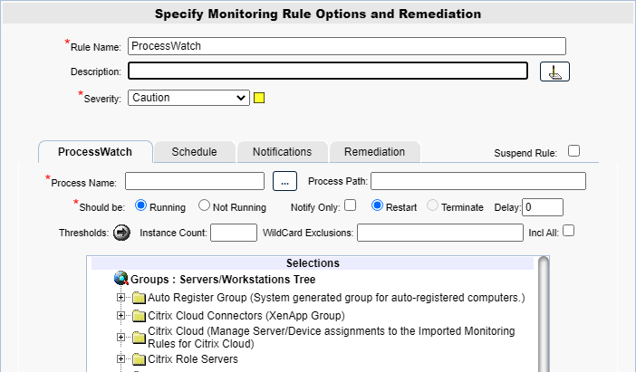

**Configure a Process Watch rule**

1. To create a new monitoring condition, navigate to the **Configure - Monitoring Rules** page and click the **New** button
2. A selection pane will appear, select the radio button option for **Process Watch** and then click **OK**
3. Now the monitoring rule pane will appear. At the top of the pane name the Monitoring Rule via the **Rule Name** field, as well as define the description and the severity.
4. The first tab, **ProcessWatch** is where you will define condition(s) to be monitored
5. In the **Process Name** field, define the process to be monitored.
   1. The single asterisk (‘*’) Wildcard character is supported, and when specified, all processes are monitored against the specified thresholds.
      1. When selecting this option it will also disable the ‘should be running or not running’ options along with the remediation to restart the process.
   2. Use the asterisk (‘*’) Wildcard character as part of a Process Name to refer to a group of like named processes, for example, a Process Name of ‘abc*’ (exclude the quotes when actually using) would match any process name that started out with the characters ‘abc… '
   3. You can also use the ‘…’ button to find processes that are currently running on a specific server
6. In the **Process Path** field, define the fully qualified path for the Process being monitored.
   1. This is only applicable and required if the **Restart** option is selected.
   2. The path includes the driver letter but does NOT include the machine name.  For example, "C:\Program Files\MyProcesses\Process.exe" is a correct specification.
7. In the **Should be** field, define whether or not the process(es) being monitoring should always be running or should never be running using the radio button options.
   1. You can disable this option by editing the process name field as described in steps 5.1-5.3.
8. The **Notify Only** check box, when checked, will alert you on the monitoring condition and will not try to terminate or restart the process.
9. The **Restart** radio button, when selected, will alert you on the monitoring condition AND will attempt to restart the process.
   1. This field is defaulted when the ‘Running’ option is selected.
   2. You can disable this option by using the process name field as described in steps 2.1-2.3.
10. The **Terminate** radio button, when selected, will alert you on the monitoring condition AND will attempt to terminate the process.
    1. This field is defaulted when then **Not Running** radio button for **Should be** is selected.
11. In the **Delay** field, optionally specify a duration value in minutes that the process is detected as running or not running before the alert condition triggers.
12. In the **Thresholds** field, click the arrow button to view the optional threshold parameters to monitor CPU and memory utilization of a running process.
13. In the **Instance Count** field, optionally define the minimum number of instances for a process that should be running; if the number of instances of the specified process running is less than this then an alert condition exists.
    1. If the  **Not Running** radio button for **Should be** is selected, then this count defines a 'ceiling' such that if the instance count of the specified process is equal to or greater than this count, then an alert condition exists
    2. If the  **Terminate** option is selected then instances of the specified process will be terminated until the number of instances is less than this count.
14. The **WildCard** **Exclusions** field is only applicable if there is a WildCard ‘*’ specified in the **Process Name** field.
    1. Optional parameter, if specified defines one or more processes, separated by a semi-colon, that are excluded from the process check.
15. The **Incl All** check box, meaning include all, when enabled when using a wild-card specification for the Process Name and you want the CUMULATIVE CPU Utilization of all processes that match the wild-card to be checked against the Threshold ‘CPU (%)’.
16. In the **Selections** tree, select the servers/workstations that you want to monitor the specified condition on.

**Configure the Schedule**

The **Schedule** tab of a monitoring rule allows users to define how frequently the rule will alert. This can be done by adjusting the following fields:

* **Alert Every Time**: Defines whether an alert is generated every time the conditions are on the previous tab are met.
  + When checked the alert is generated every time the conditions are met.
  + When unchecked, the alert is only generated if the alert conditions are met, and the Minimal Notification Interval is exceeded since the last alert for this type.
* **Minimal Notification Interval**: Defines the minimal interval that must elapse between events for this alert before another alert will be generated.
  + The Alert Every Time checkbox must be unchecked in order to use this option.
  + For ServerWatch IP Services, this also defines the minimum elapsed time since a service is first detected as down or failed before an alert is generated.
* **Maximum Notification Interval**: Defines the maximum number of times you want to be notified during a continuous failure situation.
  + A value of 0 means no maximum is defined so you will continue to be notified according to your Alert Every Time and Minimal Notification Interval settings.
  + A non-zero value means that after you have been notified the number of times defined in the Maximum Alert Notifications, and according to your Alert Every Time and Minimal Notification Interval settings, you will not be notified again.
* **Notify On Restore**: Defines whether a 'Restore' alert is generated if you have previously been alerted due to a failure.
  + There is always a Notify on Restore for a ServerWatch for IP Service
* **Active Only if Server 'Owns".... This Cluster Group**: This option is for monitoring machines that are apart of a cluster. If the checkbox is checked, then the rule is monitoring and will alert only if the server is a member of a cluster, 'owns' the specified Cluster Group and the specified Cluster Group is 'Online'.

**Additional Configuration**

For additional configuration options please see the following articles:

* Enabling Notifications:
  + [Configure Email and Text Alert Notifications](https://support.goliathtechnologies.com/hc/en-us/articles/360024446933)
  + [Configure SNMP Alert Notifications](https://support.goliathtechnologies.com/hc/en-us/articles/360024726913)
  + [Configure Syslog Alert Notifications](https://support.goliathtechnologies.com/hc/en-us/articles/360024346594)
* [Configure Custom Remediation](https://support.goliathtechnologies.com/hc/en-us/articles/360024446633)